CSD 4203 Project

GROUP MEMBERS:
Minh Phuong Ly C0757038
Sai Praneeth Krishna Kotamraju C0765499
Dinh Nhat Nguyen C0746382
Supriya Supriya C0765041

Instructions:
- Use SQL Developer and provide screenshot for each question
- Run the provided appbDbcreate.sql SQL script to create the database to be used when working on this assignment.
- Use “object_Name_YourName” when you create procedure, function and triggers. For example: Create procedure STATUS_CHANGE_SAMI
- You can find all your triggers, function and procedures from object browser

Question 1. Create Report that display the product id’s and their price (1 Marks)

Create a report by creating a cursor named product_cursor that will fetch IDPRODUCT and PRICE from BB_PRODUCT table into two variables that you will declare. Use for loop to print all the product id’s and its prices.

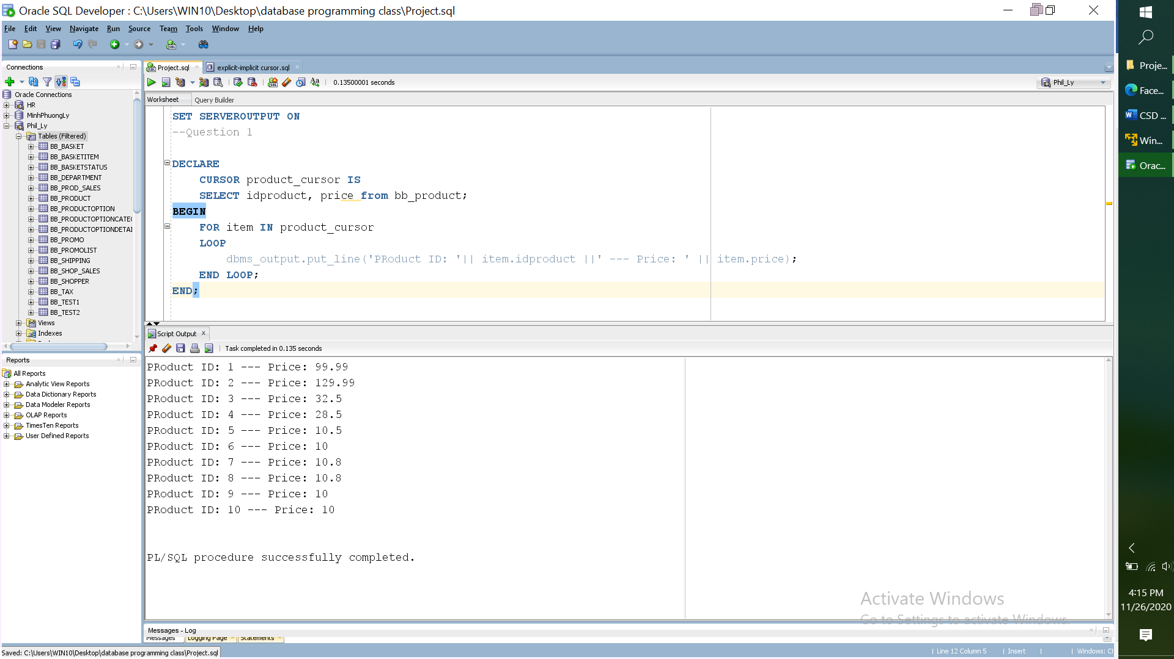
Question 2. Update the Status of an Order(2 Marks)

Create a procedure named STATUS_CHANGE that allows a company to employee in the Shipping Department to update the status of an order to add shipping information.

The procedure should allow the update of a row indicating an IDSTAGE of 1, to have ‘Picked’ as value of the column “NOTES” and SHIPPINGNUM value updated to be “11”. Use bb_basketstatus table.
Invoke the procedure with proper statement

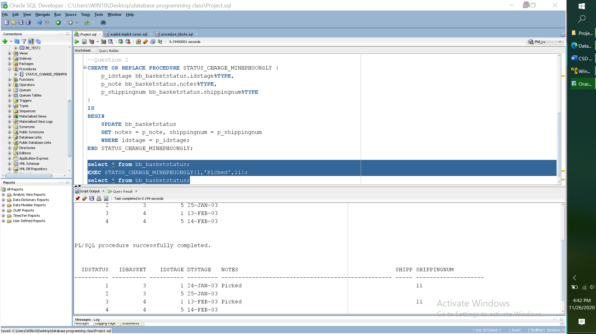
Question 3. Query the shoppers’ information(1 Marks)

Create procedure named “Shopper_info” which will accept id_shopper as parameter and it will return last name, address and email.
Test your procedure using bind variables. You may refer to bb_shopper table.
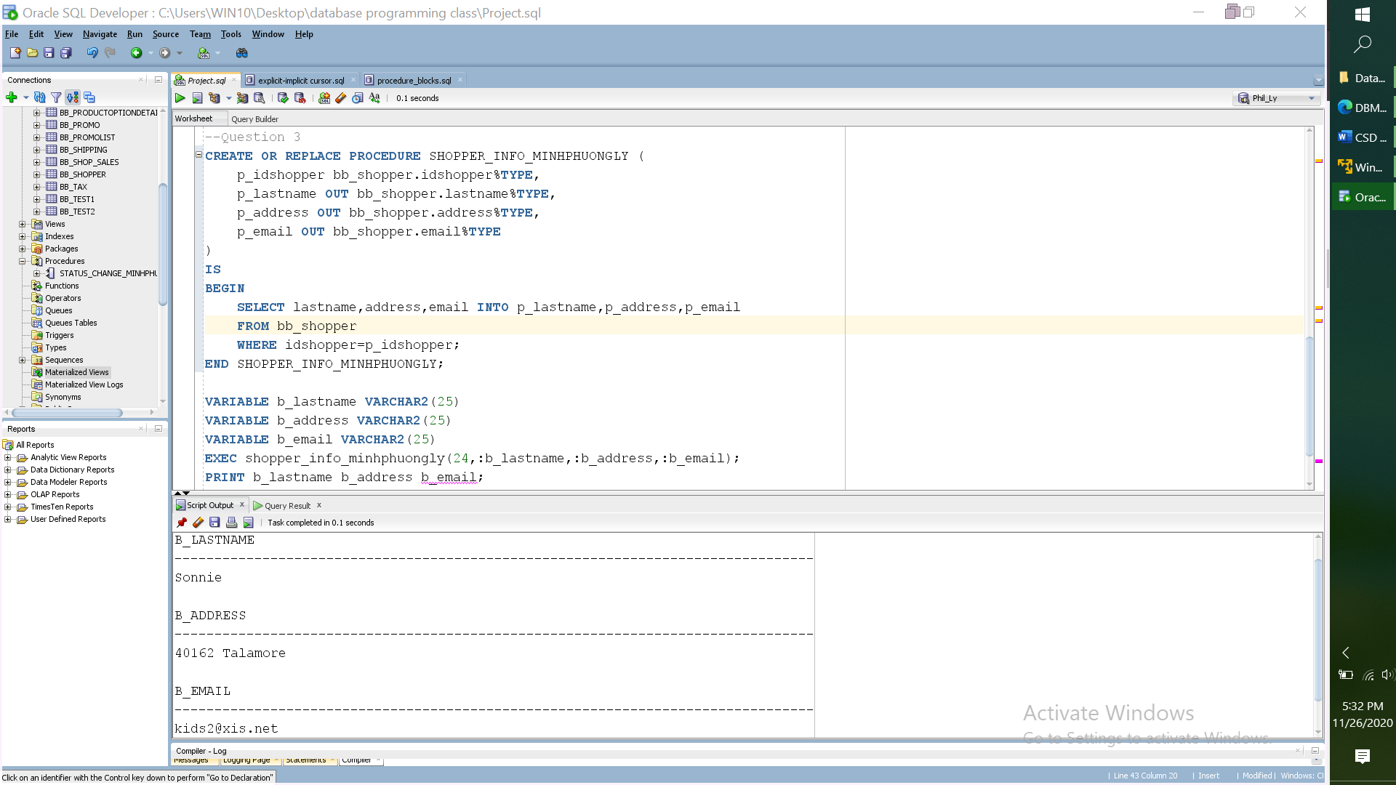

Question 4. Replenish the stock (2 Marks)

Create a procedure named Stock_Reorder that will check the stock level and if any product stock has less than 35 units, then it will update reorder column with 10 units.
Execute your procedure and display the output.

Refer to bb_product table

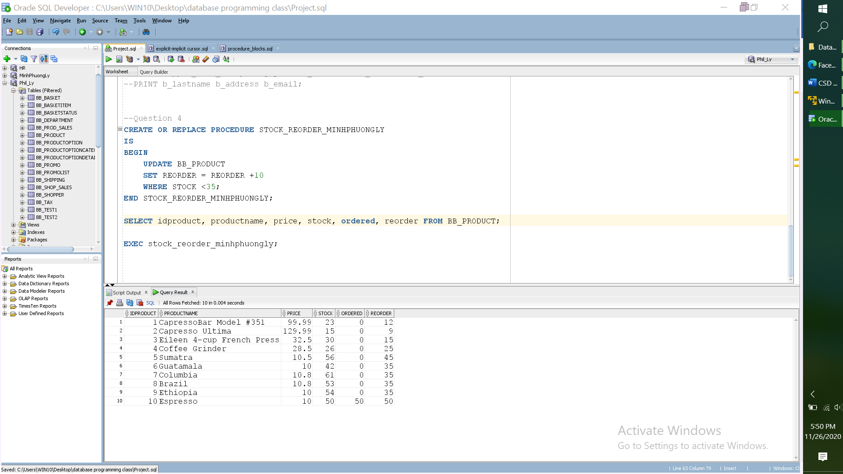
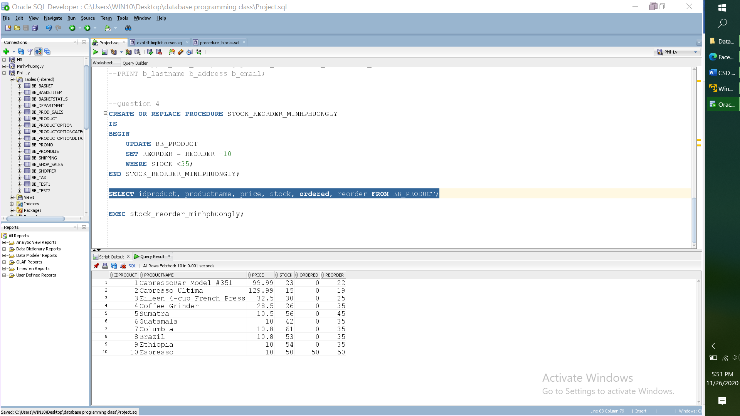
Question 6. Identify the customer with lowest number of order placed (2 Marks)

Create a function ORD_PLACED that will identify the customer with lowest total amount of order. Refer to table BB_BASKET that include IDSHOPPER column which represents customer id. Display the idshopper and the total amount of the order.

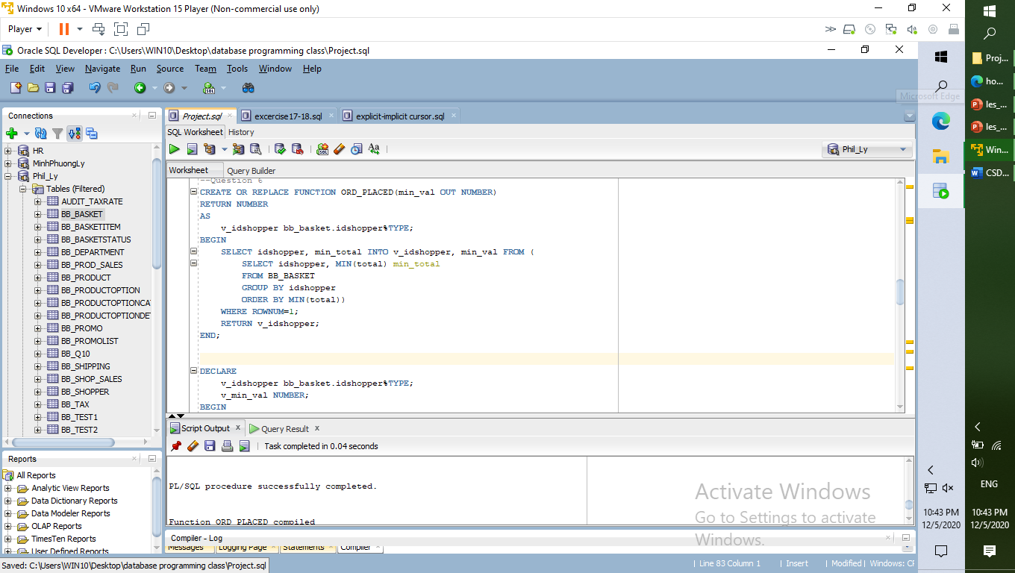

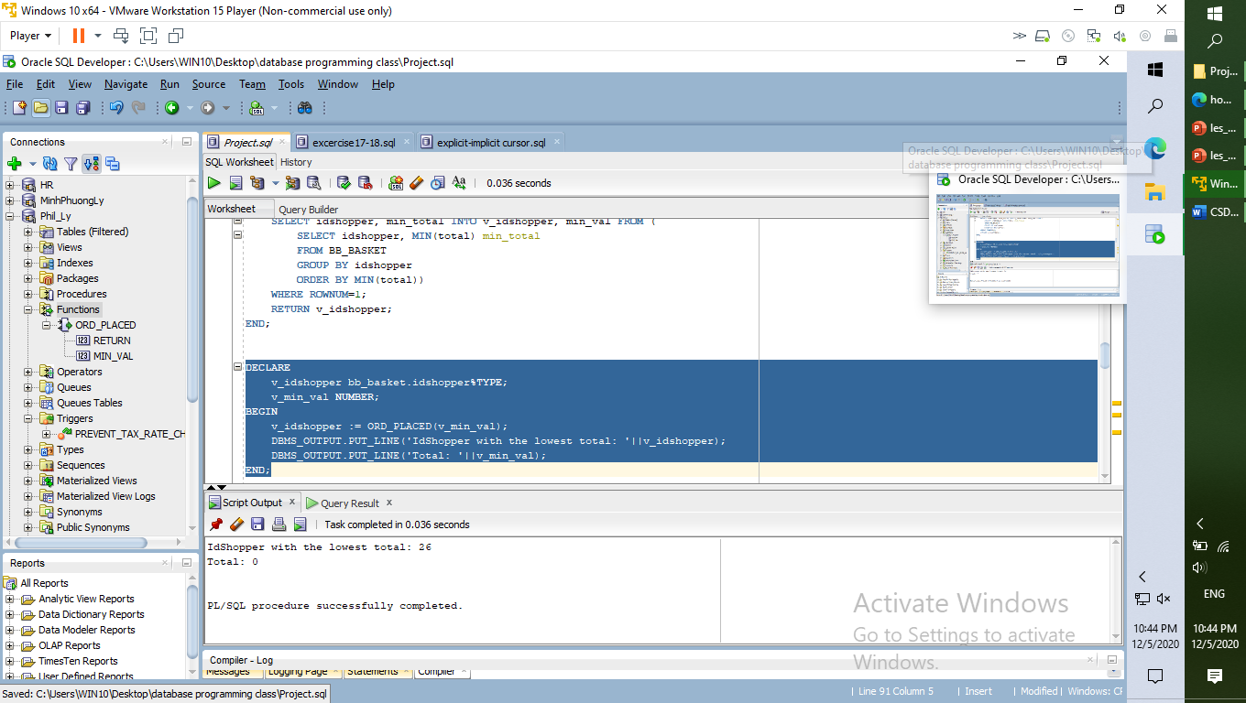
Question 7. Perform Exception Handling with User-Defined Errors (2 Marks)

In order to increase the sales of ID PRODUCT 3 and ID PRODUCT 9, the management requested that the minimum quantity of each of the above item is 10.
Create an exception that will be raised if any entered order contains IDPRODUCT 3 or 9 with less than 10 units of quantity and display the message “Minimum quantity order of this product is 10”. Test your exception with insert statement into BB_BASKETITEM table.
Refer to bb_product table in order to find related IDPRODUCT column information

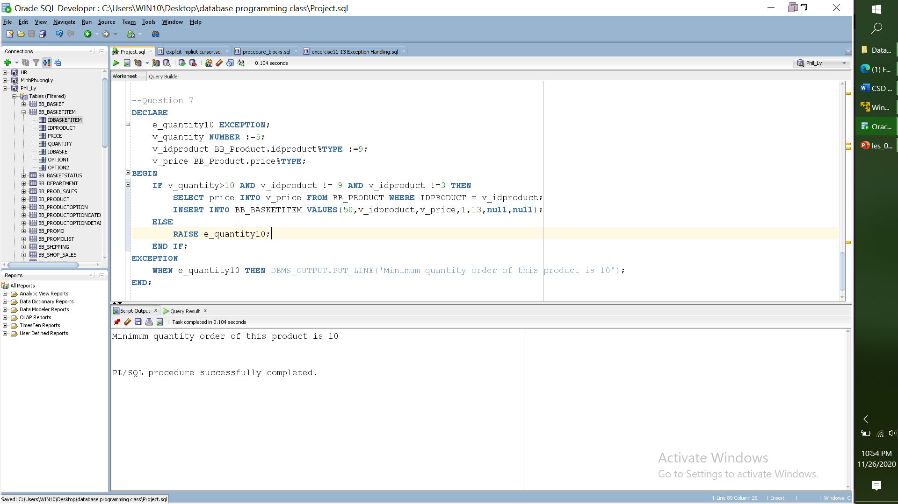
Question 8. Perform Exception Handling on Shopper information(1 Marks)
Perform Exception handling and use oracle error table that will be raised if the user entered.
If the user tried to update shopper email. Refer to bb_shopper table
Test your script and raise the exception.

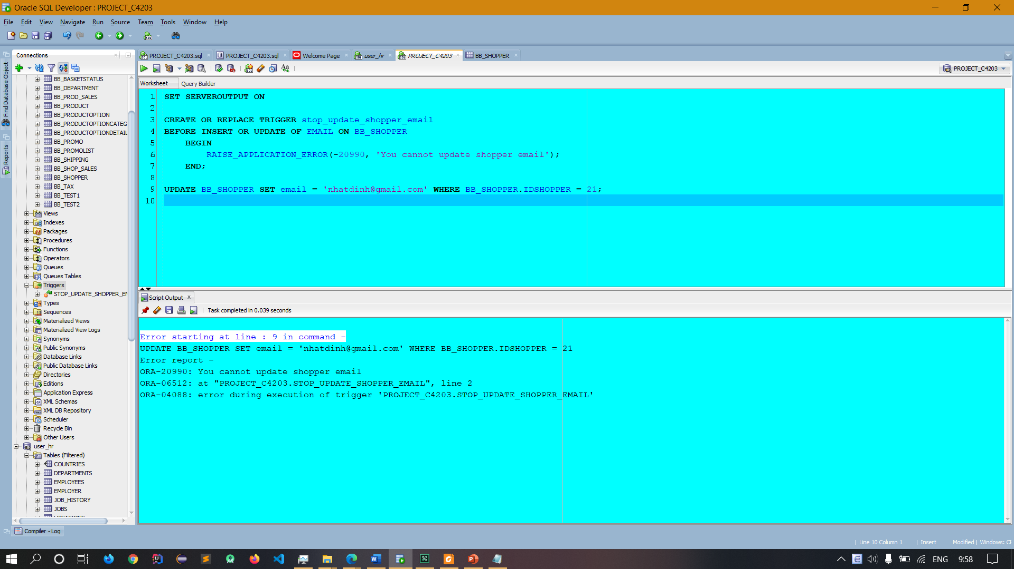
Question 9 . Refraining users to modify the total amount (2 Marks)
The Management wants to refrain the users from changing or modifying the value of the total amount in the BB_basket table. Include the following message : “You are not allowed to change the value of total amount”

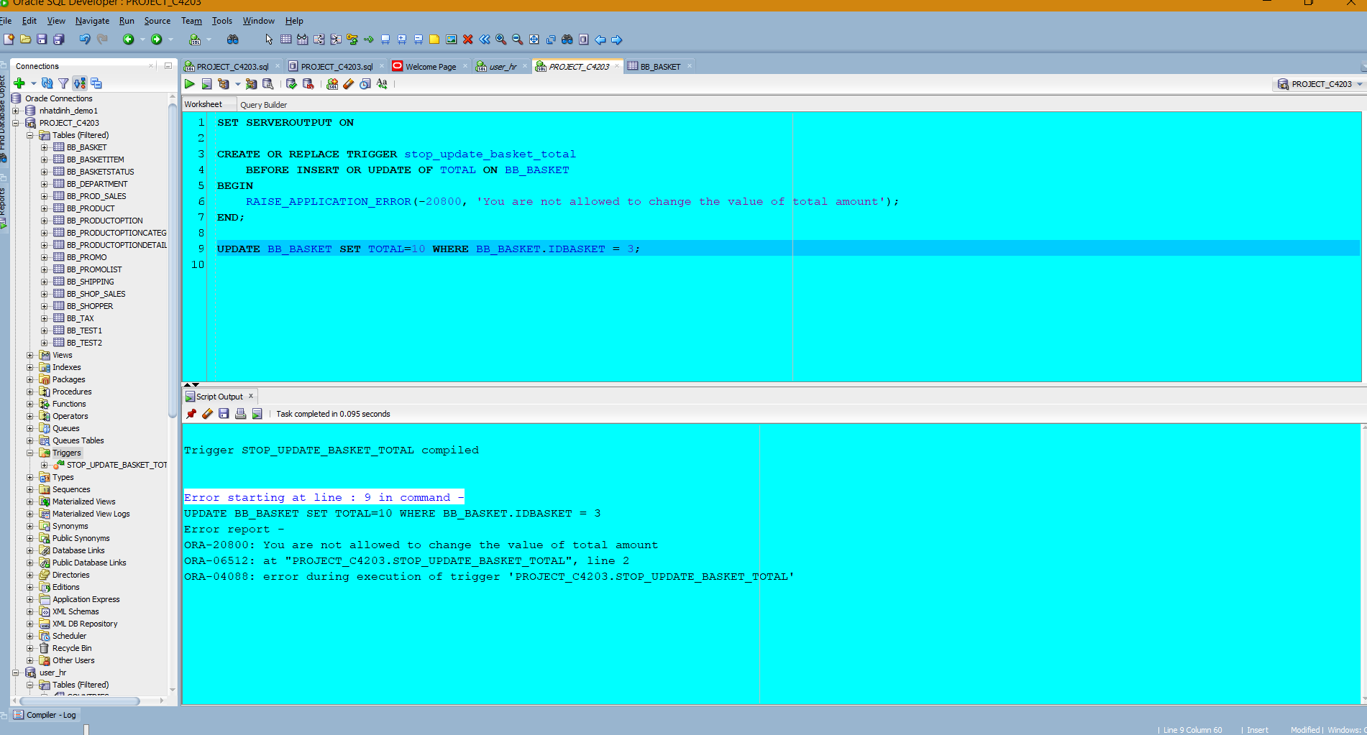
Question 10 . Refraining users to update tax rate (2 Marks)
The management wants to ensure that tax rates are not changed and also it wants to know the username of the user who attempted to change the tax rate, the old tax rate and the new tax rate that user entered. Display the table that include the following columns:username, old_taxrate, new_taxrate.

